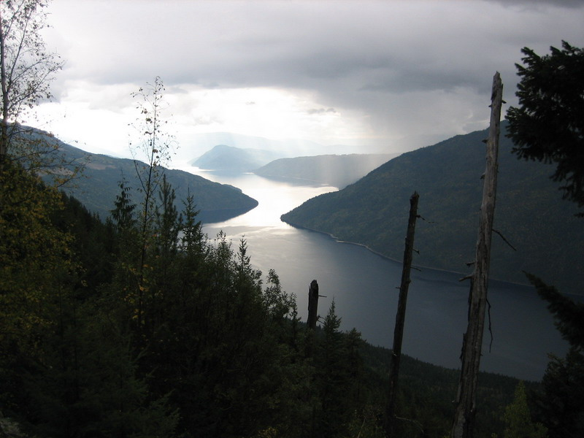
Stand Development Monitoring
Okanagan TSA Summary

THIS SUMMARY IS BASED ON DATA FROM LESS THAN 30 SURVEYED POLYGONS. THE RESULTS PRESENTED ARE CONSIDERED PRELIMINARY.

This summary is from polygons surveyed in the Okanagan TSA in 2011. This summary is an example of the variety and depth of information that can be extracted from SDM data.

Currently, SDM field survey data is entered into an EXCEL spreadsheet template. This template provides an individual polygon data summary for immediate use. These spreadsheets are then loaded into the SDM ACCESS database. The database can be queried to produce an aggregated data summary like this one that includes data from multiple polygons within a TSA. The queries can be adjusted to extract data in various combinations depending on the user’s needs.

This summary is not an analysis; it provides limited interpretation of the data. Reports examining specific questions regarding productivity or that seek to explain trends and other behaviours can be constructed based on this data along with the use of other supporting tools or evidence.

Provincial and regional Forest Health and Silviculture staff can be asked to help with the interpretation of the information presented in the summaries and in the creation of more detailed reports.

Your input as comments and suggestions are needed to further develop these summaries. Please contact Harry.Kope@gov.bc.ca and provide your suggestions for improvement.

.
STAND DEVELOPMENT MONITORING - Okanagan TSA Summary
Purpose and Audience – Data summaries can help statutory decision makers and operational foresters make informed decisions on stand development, TSR data package inputs, FSP renewals, and FFT activity priorities. They provide information on the growth and health of managed stands.
The Forest and Range Evaluation Program in conjunction with the provincial forest health program have designed an evaluation protocol (Stand Development Monitoring - SDM) that assesses the condition of post-free-growing managed stands by measuring stand attributes and the impact of biotic and abiotic damaging factors on stand health to determine whether these free-growing stands are meeting productivity expectations.
NOTE – This report provides summary information obtained from the surveyed polygons. Inferences from these summaries should be made cautiously.
This summary includes data on: Sample Summary Forest Health Stand Density Species Composition Site Index
SAMPLE SUMMARY
Polygon and polygon population attributes, and numbers and percentages of sampled live trees.
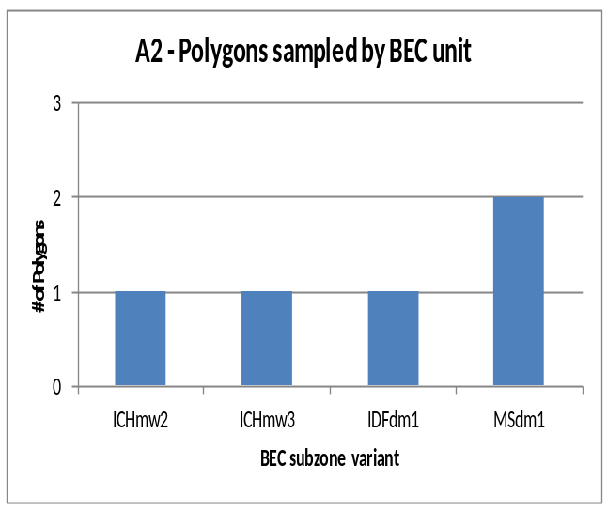
A1 – number of polygons sampled
Survey year: | 2011
DOS | 5

A3 - sampled polygon attributes
Attribute | nª | Mean | SD^{b} | Range
Polygon net area (ha) | 5 | 16.0 | 4.2 | 11 to 23
Stand Age (yrs) | 5 | 20.4 | 4.7 | 15 to 28
Harvest to Declaration (yrs) | 3 | 11.0 | 2.0 | 9 to 13
Planting to Declaration (yrs) | 2 | 6.5 | 0.7 | 6 to 7
Declaration to SDM (yrs) | 3 | 11.3 | 3.2 | 9 to 15
ª. Differing ‘n’ values indicate missing information for some polygons.
^{b}. SD - Standard Deviation

A4 - sample population coverage
TSA  polygon population  (n) | Total polygon population  area (ha) | Number Polygons  ≥5 ha  (n) | Population polygon area  ≥5 ha  (ha) | Number of polygons sampled  (n) | Sampling intensity by number of polygons | Area  sampled  (≥5 ha)  (ha) | Sampling intensity by area
2051 | 26651 | 1429 | 25042 | 5 | 0.3% | 79.8 | 0.3%

A5 - number and percentage of sampled total live trees
Tree species: | Ac | At | Bl | Cwi | Ep | Fdi | Hwi | Lw | Pli | Pw | Sx | Total
Number | 59 | 16 | 81 | 89 | 47 | 92 | 36 | 16 | 1032 | 9 | 94 | 1571
Percent | 4 | 1 | 5 | 6 | 3 | 6 | 2 | 1 | 66 | 1 | 6 | 100
X1 - Tree Species Abbreviations
Ac - Poplar Hwi – Western Hemlock (Interior)
At – Aspen Lw – Western Larch
Bl – Subalpine Fir Pli - Lodgepole Pine (Interior)
Cwi – Western red Cedar (Interior) Pw – Western white Pine
Ep – Paper Birch Sx – Spruce hybrid
Fdi – Douglas-fir (Interior)

FOREST HEALTH
Forest Health is assessed using the SDM damage criteria for mid-rotation stands (see Appendix 1). The damage criteria establish forest health threshold tolerances identifying unacceptable and damaged trees, which are labelled pest affected trees. In the Okanagan TSA the pathogen most recorded was Western Gall Rust (DSG); the animal damage was Squirrel (AS); the abiotic damage was Vegetation competition (VT).
B1 – average stems per ha by forest health status
X2 – tree layers
Layer 1 >12.5 cm dbh
Layer 2 7.5 to 12.5 cm dbh
Layer 3 >1.3 m in height to 7.49 cm dbh
District | Live Acceptable Trees (sph) | Live Unacceptable Trees (sph) | Dead Unacceptable Trees (sph) | Total Stemsª (sph)
DOS | 4408 | 1876 | 344 | 6628  X3 – forest health abbreviations  DSG – Western gall rust AB – Bear  DRA – Armillaria root disease AC – Cattle  DMP – Lodgepole Pine mistletoe VT - Vegetation competition  DSB - White Pine blister rust NY – Snow press  DRB – Black stain root disease  AS – Squirrel  U - Unknown
ª For forest health purposes total stems equals all live trees plus all dead trees.
B2 - forest health factors detected
(Brackets are the number of plots with a specific forest health factor. Plots =50)
Pathogen DSG (13) DRA (9) DMP (3) DSB (3) DRB (1)
Insect
Animal AS (7) AB (1) AC (1)
Abiotic VT (29) NY (10)
Unknown U (8)

B3 - incidence of forest health factor by bec
BEC | Tree Layer | Total Stems | Acceptable Trees |  |  | Unacceptable Trees |  |  |  |  |  | Percent incidence^{c} of Forest Health Factor^{d} for each tree layer
 |  |  |  |  |  | Live |  |  | Dead
BEC | Tree Layer | Total Stems | n | (%^{b}) | n |  | (%^{b}) | n |  | (%^{b}) | DSG |  | DRA | DMP | DSB | DRB | AS | AB | AC | VT | NY | Other | U
ICHmw2 | 2 | 9 | 8 |  | 1 |  |  | 0 |  |  | - |  | - | - | - | - | - | 11.1 | - | - | - | - | -
 | 3 | 96 | 93 |  | 3 |  |  | 0 |  |  | 1.0 |  | - | - | - | - | - | 1.0 | - | - | - | 1.0 | -
 |  | 105 | 101 | (96.2) | 4 |  | (3.8) | 0 |  | (0.0) | 1.0 |  | 0.0 | 0.0 | 0.0 | 0.0 | 0.0 | 1.9 | 0.0 | 0.0 | 0.0 | 1.0 | 0.0
ICHmw3 | 1 | 20 | 19 |  | 1 |  |  | 0 |  |  | - |  | - | - | - | - | - | - | - | - | - | 5.0 | -
 | 2 | 50 | 46 |  | 3 |  |  | 1 |  |  | - |  | 2.0 | - | 4.0 | - | - | - | - | - | - | 2.0 | -
 | 3 | 198 | 160 |  | 28 |  |  | 10 |  |  | - |  | 1.5 | - | 1.5 | - | - | - | - | 16.2 | - | - | -
 |  | 268 | 225 | (84.0) | 32 |  | (11.9) | 11 |  | (4.1) | 0.0 |  | 1.5 | 0.0 | 1.9 | 0.0 | 0.0 | 0.0 | 0.0 | 11.9 | 0.0 | 0.7
IDFdm1 | 2 | 28 | 28 |  | 0 |  |  | 0 |  |  | - |  | - | - | - | - | - | - | - | - | - | - | -
 | 3 | 401 | 231 |  | 165 |  |  | 5 |  |  | 1.2 |  | - | 0.7 | - | 0.2 | 0.2 | - | 0.2 | 38.4 | 1.0 | 0.2 | -
 |  | 429 | 259 | (60.4) | 165 |  | (38.5) | 5 |  | (1.2) | 1.2 |  | 0.0 | 0.7 | 0.0 | 0.2 | 0.2 | 0.0 | 0.2 | 35.9 | 0.9 | 0.2 | 0.0
MSdm1 | 1 | 36 | 32 |  | 4 |  |  | 0 |  |  | 2.8 |  | - | - | - | - | 5.6 | - | - | - | - | 2.8 | -
 | 2 | 145 | 132 |  | 13 |  |  | 0 |  |  | 2.8 |  | - | - | - | - | 4.1 | - | - | - | - | 2.1 | -
 | 3 | 654 | 353 |  | 251 |  |  | 50 |  |  | 0.9 |  | - | 0.2 | - | - | 0.2 | - | - | 40.8 | 3.7 | 0.3 | -
 |  | 835 | 517 | (61.9) | 268 |  | (32.1) | 50 |  | (6.0) | 1.3 |  | 0.0 | 0.1 | 0.0 | 0.0 | 1.1 | 0.0 | 0.0 | 32.0 | 2.9 | 0.7 | 0.0
a. Averages on a per ha basis b. For forest health purposes total stems equals total live plus total dead c. Percent of the total stems d. Only the top 13 forest health factors are included in the table

B4 - incidence of forest health factor by tree species
Tree Species | Tree Layer | Total Stems | Acceptable Trees |  |  | Unacceptable Trees |  |  |  |  |  | Percent incidence^{c} of Forest Health Factor^{d} for each tree layer
 |  |  |  |  |  | Live |  |  | Dead
Tree Species | Tree Layer | Total Stems | n | (%^{b}) | n |  | (%^{b}) | n |  | (%^{b}) | DSG |  | DRA | DMP | DSB | DRB | AS | AB | AC | VT | NY | Other | U
At | 1 | 5 | 5 |  |  |  |  |  |  | - | - |  | - | - | - | - | - | - | - | - | - | - | -
 | 2 | 18 | 17 |  | 0 |  |  | 1 |  |  | - |  | - | - | - | - | - | - | - | - | - | 5.6 | -
 | 3 | 53 | 53 |  | 0 |  |  | 0 |  | - | - |  | - | - | - | - | - | - | - | - | - | - | -
 |  | 76 | 75 | (98.7) | 0 |  | (0.0) | 1 |  | (1.3) | 0.0 |  | 0.0 | 0.0 | 0.0 | 0.0 | 0.0 | 0.0 | 0.0 | 0.0 | 0.0 | 1.3 | 0.0
Bl | 2 | 10 | 10 |  | 0 |  |  | 0 |  |  | - |  | - | - | - | - | - | - | - | - | - | - | -
 | 3 | 77 | 56 |  | 15 |  |  | 6 |  |  | - |  | - | - | - | - | - | - | - | 27.3 | - | - | -
 |  | 87 | 66 | (75.9) | 15 |  | (17.2) | 6 |  | (6.9)
Cwi | 1 | 10 | 9 |  | 1 |  |  | 0 |  |  | - |  | - | - | - | - | - | - | - | - | - | 10.0 | -
 | 2 | 10 | 10 |  | 0 |  |  | 0 |  |  | - |  | - | - | - | - | - | - | - | - | - | - | -
 | 3 | 69 | 62 |  | 7 |  |  | 0 |  |  | - |  | - | - | - | - | - | - | - | 10.1 | - | - | -
 |  | 89 | 81 | (91.0) | 8 |  | (9.0) | 0 |  | (0.0) | 0.0 |  | 0.0 | 0.0 | 0.0 | 0.0 | 0.0 | 0.0 | 0.0 | 7.9 | 0.0 | 1.1 | 0.0
Ep | 1 | 3 | 3 |  | 0 |  |  | 0 |  |  | - |  | - | - | - | - | - | - | - | - | - | - | -
 | 2 | 4 | 4 |  | 0 |  |  | 0 |  |  | - |  | - | - | - | - | - | - | - | - | - | - | -
 | 3 | 40 | 39 |  | 1 |  |  | 0 |  |  | - |  | - | - | - | - | - | - | - | 2.5 | - | - | -
 |  | 47 | 46 | (97.9) | 1 |  | (2.1) | 0 |  | (0.0) | 0.0 |  | 0.0 | 0.0 | 0.0 | 0.0 | 0.0 | 0.0 | 0.0 | 2.1 | 0.0 | 0.0 | 0.0
Fdi | 1 | 1 | 1 |  | 0 |  |  | 0 |  |  | - |  | - | - | - | - | - | - | - | - | - | - | -
 | 2 | 17 | 16 |  | 1 |  |  | 0 |  | - | 5.9 |  | - | - | - | - | - | - | - | - | - | - | -
 | 3 | 79 | 59 |  | 15 |  |  | 5 |  | - | 3.8 |  | - | - | - | - | - | - | - | 21.5 | - | - | -
 |  | 97 | 76 | (78.4) | 16 |  | (16.5) | 5 |  | (5.2) | 0.0 |  | 4.1 | 0.0 | 0.0 | 0.0 | 0.0 | 0.0 | 0.0 | 17.5 | 0.0 | 0.0 | 0.0
Hw | 1 | 2 | 2 |  | 0 |  |  | 0 |  |  | - |  | - | - | - | - | - | - | - | - | - | - | -
 | 2 | 7 | 7 |  | 0 |  |  | 0 |  |  | - |  | - | - | - | - | - | - | - | - | - | - | -
 | 3 | 30 | 23 |  | 4 |  |  | 3 |  |  | - |  | - | - | - | - | - | - | - | 23.3 | - | - | -
 |  | 39 | 32 | (82.1) | 4 |  | 10.3) | 3 |  | (7.7) | 0.0 |  | 0.0 | 0.0 | 0.0 | 0.0 | 0.0 | 0.0 | 0.0 | 17.9 | 0.0 | 0.0 | 0.0
Lw | 1 | 1 | 1 |  | 0 |  |  | 0 |  |  | - |  | - | - | - | - | - | - | - | - | - | - | -
 | 2 | 6 | 6 |  | 0 |  |  | 0 |  |  | - |  | - | - | - | - | - | - | - | - | - | - | -
 | 3 | 9 | 4 |  | 5 |  |  | 0 |  |  | - |  | - | - | - | - | - | - | - | 44.4 | 11.1 | - | -
 |  | 16 | 11 | (68.8) | 5 |  | (31.3) | 0 |  | (0.0) | 0.0 |  | 0.0 | 0.0 | 0.0 | 0.0 | 0.0 | 0.0 | 0.0 | 25.0 | 6.3 | 0.0 | 0.0
Pli | 1 | 32 | 28 |  | 4 |  |  | 0 |  |  | 3.1 |  | - | - | - | - | 6.3 | - | - | - | - | 3.1 | -
 | 2 | 147 | 134 |  | 13 |  |  | 0 |  |  | 2.0 |  | - | - | - | - | 4.1 | 0.7 | - | - | - | 2.0 | -
 | 3 | 894 | 468 |  | 385 |  |  | 41 |  |  | 1.3 |  | - | 0.4 | - | 0.1 | 0.2 | 0.1 | 0.1 | 42.1 | 2.8 | 0.4 | -
 |  | 1073 | 630 | (58.7) | 402 |  | (37.5) | 41 |  | (3.8) | 1.5 |  | 0.0 | 0.4 | 0.0 | 0.1 | 0.9 | 0.2 | 0.1 | 35.0 | 2.3 | 0.7 | 0.0
Pw | 1 | 2 | 2 |  | 0 |  |  | 0 |  |  | - |  | - | - | - | - | - | - | - | - | - | - | -
 | 2 | 4 | 2 |  | 2 |  |  | 0 |  |  | - |  | - | - | 50.0 | - | - | - | - | - | - | - | -
 | 3 | 5 | 2 |  | 1 |  |  | 2 |  |  | - |  | - | - | 60.0 | - | - | - | - | - | - | - | -
 |  | 11 | 6 | (54.5) | 3 |  | (27.3) | 2 |  | (18.2) | 0.0 |  | 0.0 | 0.0 | 45.5 | 0.0 | 0.0 | 0.0 | 0.0 | 0.0 | 0.0 | 0.0 | 0.0
Sx | 2 | 9 | 8 |  | 1 |  |  | 0 |  |  | - |  | - | - | - | - | - | - | - | - | - | 11.1 | -
 | 3 | 93 | 71 |  | 14 |  |  | 8 |  |  | - |  | - | - | - | - | - | - | - | 21.5 | 2.2 | - | -
 |  | 102 | 79 | (77.5) | 15 |  | (14.7) | 8 |  | (7.8) | 0.0 |  | 0.0 | 0.0 | 0.0 | 0.0 | 0.0 | 0.0 | 0.0 | 19.6 | 2.0 | 1.0 | 0.0
ª Percent based on total stems (live and dead); ^{b} Percent incidence of the total stems of a layer for each FHF; ^{c} Only the top FHF are listed, the Other column contains the minor FHF not listed.

STAND DENSITY
To produce a free-growing crop of trees a stand is managed to the target stocking level of well-spaced, preferred and acceptable species. Over time, changes in stand density may reflect tree competition, mortality due to pests, stand treatments, natural ingress or other influences.
C1 - number of polygons with changes to stand density
Nadina
Change in Total Stand Density  Total Trees (n=5) |  | Change in Stocking Density  Well-Spaced Trees (n= 5)
Decreasing | 3 | Decreasing | 4
Increasing | 2 | Increasing | 1
Data missing |  | Data missing

C2 - stand density attributes by bec – pre-sdm and at sdm
 | ICHmw2 |  | ICHmw3 |  |  | IDFdm1 |  |  | MSdm1 |  |  | ALL
 | N | Mean (sph) |  | N | Mean (sph) |  | N | Mean (sph) |  | N | Mean (sph) |  | N | Mean (sph)
Total Density pre-SDM | 1 | 2152 |  | 1 | 8016 |  | 1 | 9123 |  | 2 | 5706 |  | 5 | 6140
Total Density at SDM | 1 | 2100 |  | 1 | 5120 |  | 1 | 8480 |  | 2 | 7800 |  | 5 | 6260
Change in Total Density | 1 | -52 |  | 1 | -2896 |  | 1 | -643 |  | 2 | 2095 |  | 5 | 120
Change in Total Density (%) | 1 | -2 |  | 1 | -36 |  | 1 | -7 |  | 2 | 37 |  | 5 | 2
WS density pre-SDM) | 1 | 1088 |  | 1 | 1168 |  | 1 | 1338 |  | 2 | 1181 |  | 5 | 1191
WS density at SDM) | 1 | 1040 |  | 1 | 1040 |  | 1 | 1380 |  | 2 | 990 |  | 5 | 1088
Change in WS density) | 1 | -48 |  | 1 | -128 |  | 1 | 42 |  | 2 | -191 |  | 5 | -103
Change in WS density (%) | 1 | -4 |  | 1 | -11 |  | 1 | 3 |  | 2 | -16 |  | 5 | -9
FG density pre-SDM) | 1 | 1072 |  | 1 | 1096 |  | 1 | 1338 |  | 2 | 1000 |  | 5 | 1101
FG density at SDM | 1 | 1040 |  | 1 | 1040 |  | 1 | 1380 |  | 2 | 990 |  | 5 | 1088

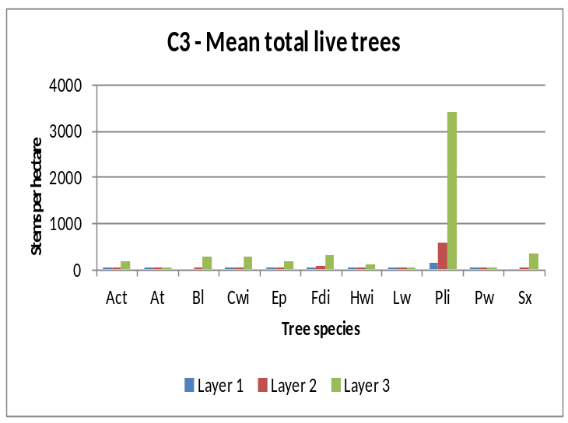
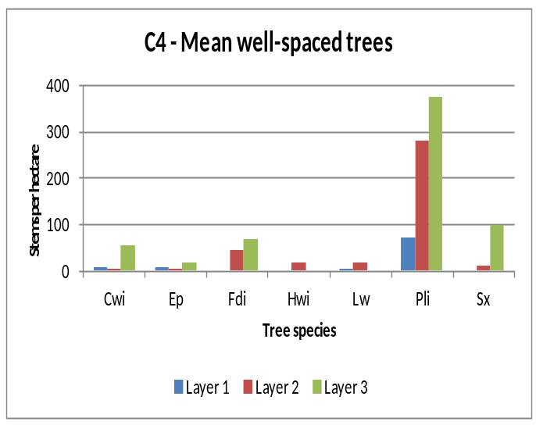

SPECIES COMPOSITION
Inventory labels are condensed representations of several stand attributes that describe conditions at the time of assessment. These attributes include leading, secondary and minor tree species by percentage class (usually rounded to the nearest 10%), average age and height of the dominant and co-dominant trees, a site index estimate, an estimate of crown closure, and the total trees per hectare. Inventory labels provide inputs used by the TASS stand model and by timber supply analysts projecting future stand development for timber supply purposes.
D1 - change in leading species between pre-sdm and sdm assessments
Leading Species at SDM | Leading Species Pre-SDM
Leading Species at SDM | ICHmw2 |  |  |  |  |  |  | ICHmw3 |  |  |  |  |  | IDFdm1 |  |  |  |  |  |  |  | MSdm1 |  |  |  |  |  | All
Leading Species at SDM |  |  | Fdi | Pli |  |  |  |  |  | Fdi | Pli |  |  |  |  |  | Fdi | Pli |  |  |  |  |  | Fdi | Pli |  |  |  |  |  | Fdi | Pli
Fdi |  |  | 0 |  |  |  |  |  |  | 1 |  |  |  |  |  |  | 0 |  |  |  |  |  |  | 0 |  |  |  |  |  |  | 1
Pli |  |  |  | 1 |  |  |  |  |  |  | 0 |  |  |  |  |  |  | 1 |  |  |  |  |  |  | 2 |  |  |  |  |  |  | 4
Total |  |  | 0 | 1 |  |  |  |  |  | 1 | 0 |  |  |  |  |  | 0 | 1 |  |  |  |  |  | 0 | 2 |  |  |  |  |  | 1 | 4
(Shaded values indicate those polygons where the leading species has NOT changed). .
(In this TSA, no change in leading species was found in 5 (100%) of the 5 polygons sampled.)

D2 – tree species and layer used to calculate mean basal area
 | Number of Trees |  |  |  |  |  | Mean Polygon BA (m²/ha)
Tree spp. | Layer 1 |  | Layer 2 |  | All | Tree spp. | Layer 1 |  | Layer 2 |  | All
 | Live | Dead | Live | Dead |  |  | Live | Dead | Live | Dead
Act | 3 | 1 | 11 | - | 15 | Act | 0.19 | 0.06 | 0.35 | - | 0.60
Cwi | 11 | - | 9 | - | 20 | Cwi | 1.42 | - | 0.26 | - | 1.68
Fdi | 1 | - | 17 | - | 18 | Fdi | 0.07 | - | 0.54 | - | 0.61
Pli | 32 | - | 148 | - | 180 | Pli | 2.66 | - | 4.09 | - | 6.75
Minor spp | 13 | - | 42 | - | 55 | Minor spp | 0.96 | - | 1.22 | - | 2.18
Total | 60 | 1 | 227 | 0 | 288 | Total | 5.31 | 0.06 | 6.46 | 0 | 11.83
% by layer | 20.8 | 0.3 | 78.8 | 0.0 |  | % by layer | 44.9 | 0.5 | 54.6 | 0.0
(Minor spp. include: At, Bl, Ep, Hwi, Lw, Pw and Sx)

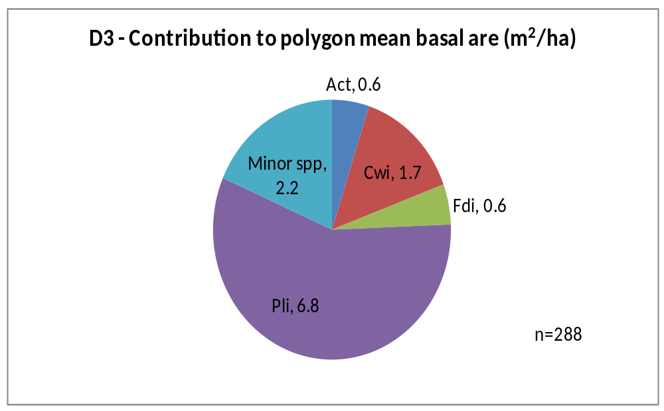

SITE INDEX
Site index was estimated using the growth intercept method. The estimates are the mean values of all available trees for that species in a BEC. Many stands do not have site index estimates recorded prior to the SDM survey.

E1 - mean site index estimate for dominant conifer species
 | Cwi |  | Fdi |  | Hwi |  |  | Lw |  | Pli |  | Sx |  | Total
BEC | N | Mean | N | Mean | N | Mean | N |  | Mean | N | Mean | N | Mean | N
ICHmw2 | - | - | - | - | - | - | - |  | - | 9 | 18.6 | 1 | 21.8 | 10
ICHmw3 | 3 | 15.2 | 4 | 25.2 | 2 | 21.6 | - |  | - | - | - | - | - | 9
IDFdm1 | - | - | - | - | - | - | - |  | - | 9 | 19.0 | - | - | 9
MSdm1 | - | - | - | - | - | - | 1 |  | 23.8 | 18 | 20.8 | - | - | 19
 | 3 | 15.2 | 4 | 25.2 | 2 | 21.6 | 1 |  | 23.8 | 36 | 19.8 | 1 | 21.8 | 47

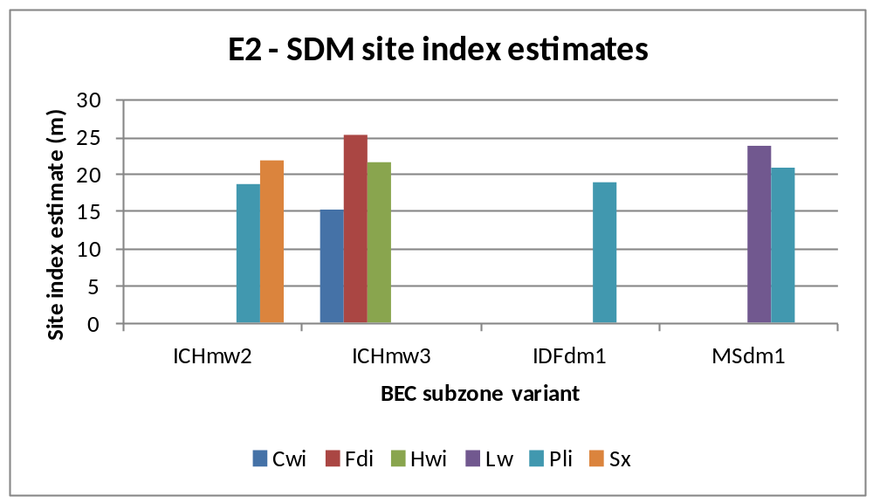

APPENDIX 1
BEC codes - http://www.for.gov.bc.ca/hre/becweb/index.html
Conifer pest codes - http://www.for.gov.bc.ca/hfp/health/fhdata/FS747%20conifer%2020111003.pdf
Conifer Tree Species codes http://www.for.gov.bc.ca/his/results/webhelp/index.htm
Deciduous pest codes - http://www.for.gov.bc.ca/hfp/health/fhdata/FS747%20deciduous%2020111003.pdf
SDM damage criteria - http://www.for.gov.bc.ca/hfp/silviculture/Surveys/SDM_Damage_Criteria_Feb_12_2010(2).pdf
SDM field cards - http://www.for.gov.bc.ca/ftp/HFP/external/!publish/FREP/indicators/FS%201357-SDMCard%20March%2012%2009.pdf
SDM survey protocol http://www.for.gov.bc.ca/ftp/HFP/external/!publish/FREP/Indicators/SDM%20Protocol%202011.pdf
Stocking Standards tables - http://www.for.gov.bc.ca/hfp/silviculture/stocking_stds.htm

APPENDIX 2
The complete list of openings, and polygons used in this report are listed here

TSA=Okanagan; Survey Year=2011 District=DOS

MAPSHEET | POLYGON | Year Logged (Smry) | BEC (Smry) | Polygon Net Area (Popn) | Leading Spp @ SDM (Smry) | Stand Age (Calc) | Total Live Trees @ SDM (Smry) | WS @ SDM (Smry) | SI @ SDM (Smry)
82E 055 205 | 283 | 1983 | MSdm1 | 14.3 | Pli | 28 | 5500 | 1020 | .
82E 095 297 | 2 | 1992 | MSdm1 | 11.4 | Pli | 19 | 10100 | 960 | .
82E 098 476 | 2142 | 1996 | ICHmw2 | 15.5 | Pli | 15 | 2100 | 1040 | .
82L 052 048 | D | 1991 | IDFdm1 | 15.8 | Pli | 20 | 8480 | 1380 | .
82L 094 006 | 501 | 1991 | ICHmw3 | 22.8 | Fdi | 20 | 5120 | 1040 | .

